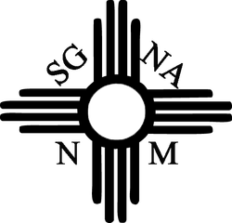

August 2, 2022

EXHIBITOR APPLICATION FOR NMSGNA FALL CONFERENCE

Vendor Booth: $600 nonrefundable exhibit fee if paid prior to October 1, 2022 (includes electrical)
$650 after October 1, 2022.

Date of Conference:
Saturday, November 12th, 2022

Site of Conference:
Isleta Resort and Casino
11000 Broadway Blvd SE.
Albuquerque, NM

Vendor Information: Information regarding set-up and delivery of product will be sent at later date.
Vendor Name:
Product Corporation:
Mailing Address:
Attention:
Business Phone:
Email Address:
Number of Exhibit Tables:
Electrical Outlet required: Yes _____ No _____
Attending Lunch: Yes _____ No _____
Additional Lunches: Yes _____ How many? _____
Accommodations with Isleta: Yes____ No _____ Call 1.877.747.5382 Group code SGN1112 Reserve by 10/21/2022
Hotel is able to receive shipments no earlier than 3 days to event. Will you have items shipped? Yes: ___ No___
How many parcelles: _____

Send application with check or money order to: (Visit www.nmsgna.org to pay with credit card and email application to nmsgna1@gmail.com).

NMSGNA
C/O Rachel Timmerman
2022 NM Rio Grande SGNA Chapter
5910 Laurel Court
Farmington, NM 87402

