ImageImage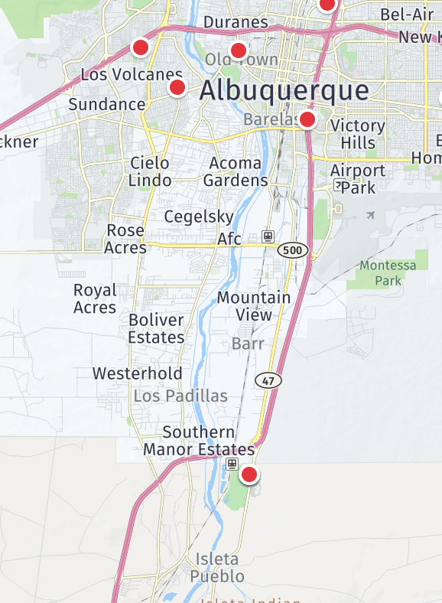

**New Mexico Rio Grande**

**SGNA Chapter #66**

**2022 Registration Form**

Name: ________________________________

Credentials: ____________________________

Home Address: _________________________

City: __________________________________

State/Zip: ______________________________

Telephone: _____________________________

Email: _________________________________

Employer: ______________________________

Employer Address: _______________________

Please send your check with copy of current SGNA membership card & registration form to:

**Rachel Timmerman**

**2021 NM Rio Grande SGNA Chapter President**

**5910 Laurel Court**

**Farmington, NM 87401**

**Questions: nmsgna1@gmail.com**

Isleta Casino & Resort

**Society of Gastroenterology Nurses & Associates**

New Mexico Rio Grande Chapter

Directions

* From I-25 North head south to exit 215. Isleta Casino & Resort is on the left side of road.
* From I-25 South head north to exit 215. Isleta Casino & Resort is on the right side of road
* Casino Address is **11000 Broadway Blvd. SE, Albuquerque, NM 87105**

November 12,2022

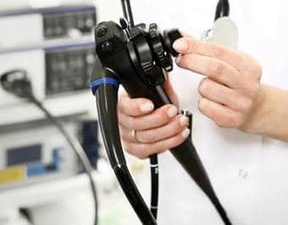Image

Conference Agenda

* 1. Catered Breakfast/Networking

800-900

910-1010 ***M***

* 1. Break/Networking

1030-1130

1130-1230

1230-1330 Catered Lunch/Time with Exhibitors

1335-1435

1440-1450 Break

1450-1550

1600-Evaluation

1605-1655



Provider of CNE Event: NM Rio Grande SGNA Region

There is no commercial support for this CNE event.

This activity has been submitted to NMNA Education for approval to award contact hours. The NMNA is accredited as an approver of nursing continuing professional development by the American Nurses Credentialing Center’s Commission on Accreditation.

Conference Registration

$65 SGNA Nurse Member

$75 Non-Member Nurse

$45 SGNA Tech Member

$50 Non-Member Tech

$30 Administrative Staff

Mail in registration by 11/01/2022

Online registration available until 11/03/2022 @ [NMSGNA.ORG](http://NMSGNA.ORG)

\***Door Registration will be an additional $15.00**

Please address check to:

**NM Rio Grande SGNA Chapter #66**

Reserve discounted rooms at Isleta Casino by using code SGN112

**Cut off date October 21, 2022**

Call (505)747-5382 or (505) 848-1999

**New Mexico Rio Grande SGNA Purposes the following:**

• to unite persons engaged in any capacity in the fields of gastroenterology and/or endoscopy nursing;

• to provide educational programs for persons in such fields

• to advance the technology, science and arts of practitioners in such fields;

• to advocate optimal care for patients with digestive disease and those undergoing diagnostic and therapeutic procedures

• to cooperate with other professional societies, corporations and governmental bodies involved in such fields.